KLE Society's

KLE Technological University



**Open Ended (OE) Assessment Report**

**On**

**ONLINE SHOPING APPLICATION**

**Object Oriented Programming (20ECSC204)  
Object Oriented Programming Lab (20ECSP203)**

Submitted by

| Name | Roll no | SRN |
| --- | --- | --- |
| KUSHAGARA  TOMAR | 201 | 01FE20BCS063 |
| YASHVARDHAN  DIWAN | 233 | 01FE20BCS098 |
|  |  |  |
| Team Number: 09 | | |

Faculty In-charge:

Mahesh Patil Sir,

SCHOOL OF COMPUTER SCIENCE & ENGINEERING

Academic year 2021-22

**Table Of Contents**

| 1. | Introduction | |
| --- | --- | --- |
|  | 1.1 | Overview of the problem statement |
|  | 1.2 | Features of Application |
| 2. | Design | |
|  | 2.1 | Class Diagrams |
| 3. | Implementation | |
|  | 3.1 | Test Plans |
|  | 3.2 | Results |

1. INTRODUCTION

1.1 OVERVIEW OF THE PROBLEM STATEMENT

With the development of the Internet, more and more people will choose to shop online. This online shopping application is designed to meet people's online shopping needs. The seller needs to input all the products into the inventory based upon the category, that he/she is trying to sell. The buyers can than browse through and purchase products. If you see the right product, you can put it in the shopping cart. When an order needs to be placed, the goods in the shopping cart will be put into the order, input relevant information into the user profile and make a payment. You can then view the order information at the end. The seller will also receive orders and obtain order information at this time.

1.2 FEATURES OF APPLICATION

* Users can create profile
* Sellers can add products in the inventory
* Buyers can add products in the shopping cart
* Users can remove items from the shopping cart
* Users can view all the available products
* Users can modify their profile details
* Users can do purchase and make payment
* Users can get order details
* Users can view products based on highest rating
* Users can view products based on lowest pricing

2. DESIGN

2.1 CLASS DIAGRAM

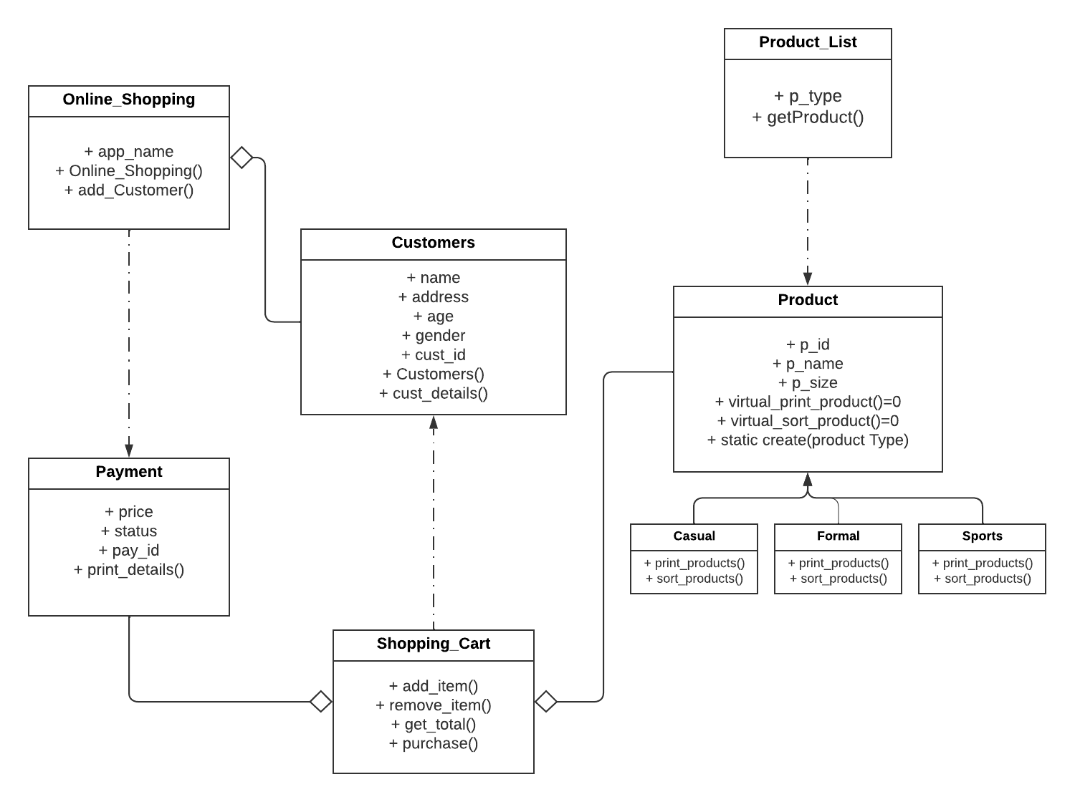

3.IMPLEMENTATION

3.1 TEST PLANS

|  |  |  |  |  |
| --- | --- | --- | --- | --- |
| **Test case number** | **Test case description** | **Input** | **Expected output** | **Test status** |
| **1** | Adding the products inside the app | Product Details | Product created | **PASS** |
| **2** | Creating the online shopping app | App details | Welcome to Meesho app | **PASS** |
| **3** | Creating the profile of the user | User details | Profile created | **PASS** |
| **4** | Adding items to the shopping cart | product | Item added to the cart | **PASS** |
| **5** | Displaying the total amount of all items present inside the cart | Products prices | Total price of all products | **PASS** |

3.2RESULT

